Techno-Commercial Offer
For

STEELUX FURNITURE PVT LTD

Dry Type Liquid Painting Booth 06th February 2025

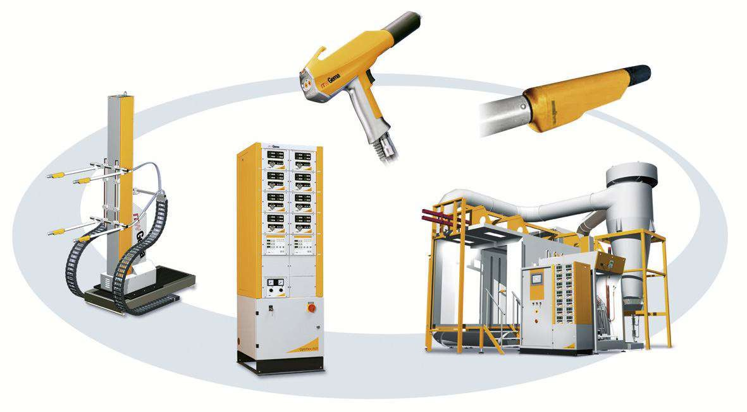

M/S STEELUX FURNITURE PVT LTD

Subject : Your Requirement of “Dry Type Liquid Painting Booth”

.

Dear Sir,

We thank you for the courtesy and interest shown in our organization & products. Further based on the discussion held with you and based on the technical data provided by you, we are submitting our Techno-Commercial proposal for the subject captioned above.

We hope you will find our technical offer meeting with your requirements and you will favor us with your valuable Order.

Please feel free to contact us for further clarifications, if any. Look forward your valuable Order at the earliest.

Thanking You

Yours faithfully,
For Value Added Coating Solution Pvt. Ltd.

Harish Sharma
(Director)
Mob: (+91) 9811846214
Email: harish@optifinish.in

TABLE OF CONTENTS
- VALUE ADDITION WITH VACSPL 4
- TECHNICAL DESCRIPTION OF LIQUID PAINTING BOOTH 4
- COMMERICIAL OFFER FOR LIQUID PAINTING BOOTH 4
- DELIVERY & PAYMENT TERMS 5
- EXCLUSIONS 6
- UTILITY PROVIDED BY CUSTOMER 7

VALUE ADDITION WITH VACSPL
  - Leader & Legend - VACSPL pioneered the powder coating technology in India.
  - Constant efforts towards developing better technology in surface coating at our R & D base.
  - Easy availability of spares assures continuous production.
  - Prompt service from our sales and service offices at Ghaziabad, Gurgaon and Rudrapur, who are technically competent to handle any eventuality.

TECHNICAL DESCRIPTION OF LIQUID PAINTING BOOTH

S. No. | Item | Description
1. | Qty. | 01 No’s
2. | Type of application | Manual
3. | Type of Booth | Side Draft Dry Type Paint Booth
4. | Overall Dimensions | 2450 x 1500 x 1800 (H) mm approx.
5. | Material of Construction | - Enclosure in 1.25 mm MS sheet  - Support member – ms sq box Pipe 40x40x2 mm
6. | Paint arrestor filter type | Paper/glass wool filter
7. | Exhaust blower’s capacity | 7,000 cm/h approx.
8. | Blower Motor | 5 HP approx.
9. | Motor mounting | Flange type
10. | Illuminations | 600-800 Lux
11. | Painting scheme | Primer followed by finish synthetic enamel paint.

COMMERICIAL OFFER FOR LIQUID PAINTING BOOTH

S. No. | Item Description | UOM | BOM | AMOUNT
1. | Side Draft Dry Type Liquid Painting Booth | No’s | 01 | 3,00,000
2. | Erection & Commissioning | Job | 01 | 30,000
TOTAL COST |  |  | INR | 3,30,000

TOTAL COST IN WORDS: - Three Lakh Thirty Thousand Rupees Only.

DELIVERY & PAYMENT TERMS

1. | Price Basis | Ex works, Noida
2. | Freight | Extra
3. | Packing (If required) | Included
4. | Transit Insurance | Extra
5. | GST | Extra
6. | Duties | Extra
7. | Delivery | 30 Days from the date of PO with advance
8. | Erection | 5-6 Days
9. | Commissioning | 2-3 Days
10. | Advance along with PO | 50%
11. | Against Inspection (PI) | 40% Basic + 100% Taxes
12. | Against Commissioning | 10%
13. | Delivery Condition | Dismantle, partly pre-assembled.
14. | Warranty | 18 months from the date of Supply or 12 months from date of  commissioning whichever is earlier.
15. | Limitation | Our liability limited to design, manufacture and supply and  installation of Plant as per enclosed scope and specs.
16. | Deserve to modification | We reserve the right to alter the plant design without  Deteriorating the utility, performance and operating safety.
17. | Right of Reserve | This Quotation is the Sole Property of VACSPL and should not  be handed over to Third Party without permission from VACSPL.
18. | Validity | 15 days

EXCLUSIONS
  - Civil Work
  - Jig & Hangers
  - All Chimney Structure
  - Roof opening & Closing for Exhaust ducts.
  - Air Supply for Auto Air Zone
  - Pit for Drain, trench
  - LPG pipe line with Filter and Regulator up to Burners.
  - Incoming power Supply for Control panels with Earthing.
  - Earthing at All panels, structure, Ovens separately
  - Stands for Jigs/Fixture, Jigs
  - Material moving Trolley
  - Material Unloading/Shifting/Cranes at site.
  - Materials shifting up to Shop floor.
  - Platform for Fume Exhaust System
  - Uniform floor level in Plant area - +/- 10 mm
  - Free power at the time of Installation and commissioning.
  - Shop floor lighting
  - Floor painting
  - Any other items required which are not stated in our offer.

UTILITY PROVIDED BY CUSTOMER
- Electricity

  - Power – 415 V + / - 5 %, 3 phase, 50 Hz + / - 2 %, 4 wire AC supply.
  - Control – 230 V + / - 5 %, single phase, 50 Hz + / - %, 2 wire AC supply.

- Compressed air of following quality and quantity
  - Dirt – lum – 1 mg / N m 3 max.
  - Water content – < 1.3 gm / Nm3; - 40 deg C p d p.
  - Oil content – < 0.1 mg / Nm3.
  - Pressure – @ 7 bar.
  - Qty. Will be provided later.
- Fuel for Heating System

  - Type – LPG/Propane/NG (Client to confirm any one)

Note: Net calorific value of LPG considered 11500 Kcal/Kg Above fuel consumption figures are under worst ambient condition @ 7.5 0 C
- Quality and Quantity of Water

  - Pressure at inlet to tank – 1.5 kg / cm 2 g. minimum.
  - Quality of water for Pre-treatment Plant. (To be consulted with chemical supplier) Notes:
- Batch requirement of water will be equal to the volume of the Tank & Continuous quantities is to be given by the chemical supplier.
- Water quantities required during initial cleaning and commissioning would be about 4 to 5 times of initial fill up quantities. Customer to take care of the same.
Notes:
  - Customer to provide above utilities free of cost during erection/trial/pre- commissioning/commissioning period.
  - All Utilities to be provided by client at the points required by VACSPL. All the control panels to be charged with MCCB and earthing to be provided by Client.

Note: The above values of utilities are tentative and may change during detail designing.

THANK YOU

FOR ANY ENQUIRY PLEASE CONTACT


Opti finish

HARISH SHARMA
(Director)
Mobile: (+91) 9811846214
Email: harish@optifinish.in

